**Assignment -> 05 - 09 - 2022**

1. **Create an user registration page with the following fields**

**Name :**

**Email :**

**Mobile :**

**City :**

**State :**

**Country :**

**PROGRAM :**

<!DOCTYPE html>

<html>

<head>

<title>Registration form</title>

</head>

<style>

div{

display: flex;

flex-direction:initial;

text-align: justify;

justify-content: center;

}

</style>

<body>

<div>

<form name="registration_form">

<label for="name">Name:</label>

<input type="text" id="name" placeholder="Enter your name" />

<br /><br />

<label for="email">Email:</label>

<input type="email" id="email" placeholder="Enter your Email-ID" />

<br /><br />

<label for="number">Mobile number:</label>

<input

type="tel"

id="number"

placeholder="Enter your mobile number"

pattern="[0-9]{10}"

/>

<br /><br />

<label for="city">City:</label>

<input type="text" id="city" placeholder="Enter your city" />

<br /><br />

<label for="state">State:</label>

<input type="text" id="state" placeholder="Enter your state" />

<br /><br />

<label for="country">Country:</label>

<input type="text" id="country" placeholder="Enter your country" />

<br /><br />

<input type="submit" value="Submit" />

</form>

</div>

</body>

</html>

**OUTPUT :**

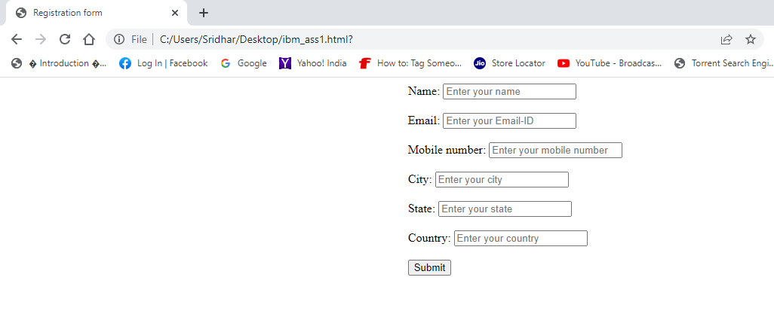

1. **Find out all input types**
2. <input type="color">
3. <input type="date">
4. <input type="datetime-local">
5. <input type="file">
6. <input type="hidden">
7. <input type="image">
8. <input type="month">
9. <input type="number">
10. <input type="radio">
11. <input type="range">
12. <input type="reset">
13. <input type="search">
14. <input type="tel">
15. <input type="time">
16. <input type="url">
17. <input type="week">